Activity 2: UML Diagram Design Project

Title:
J-PRO LIGHTS AND SOUNDS RENTALS: BOOKING AND RESERVATION SYSTEM

System Description
The J-Pro Lights and Sounds Rentals Booking and Reservation System is a web-based application designed to manage rental services for lighting and sound equipment. The system allows customers to browse available services, submit booking requests, and track their reservations. It also helps streamline the reservation process by reducing manual transactions and improving organization.
On the administrative side, the system enables the owner or staff to manage bookings, approve or reject reservation requests, update equipment availability, and monitor scheduled events. The system ensures efficient communication between customers and administrators while maintaining accurate records of all transactions.

Actors / Users
- Customer – Places booking/reservation requests
- Admin / Staff – Manages bookings, approves/rejects requests, updates system data
Main System Functions
- Register/Login (optional if included)
- View available packages/equipment
- Submit booking/reservation
- View booking status
- Cancel reservation
- Admin approves/rejects booking
- Admin manages reservations
- Admin updates availability
- Admin views all bookings

UML Diagram (Use Case Diagram)
Use Case Diagram Structure (Text Guide)
Actors:
- Customer
- Admin

SYSTEM: J-PRO BOOKING SYSTEM
Customer Use Cases:
- View Services
- Book Reservation
- View Booking Status
- Cancel Reservation
Admin Use Cases:
- Manage Bookings
- Approve Booking
- Reject Booking
- Update Availability
- View All Reservations

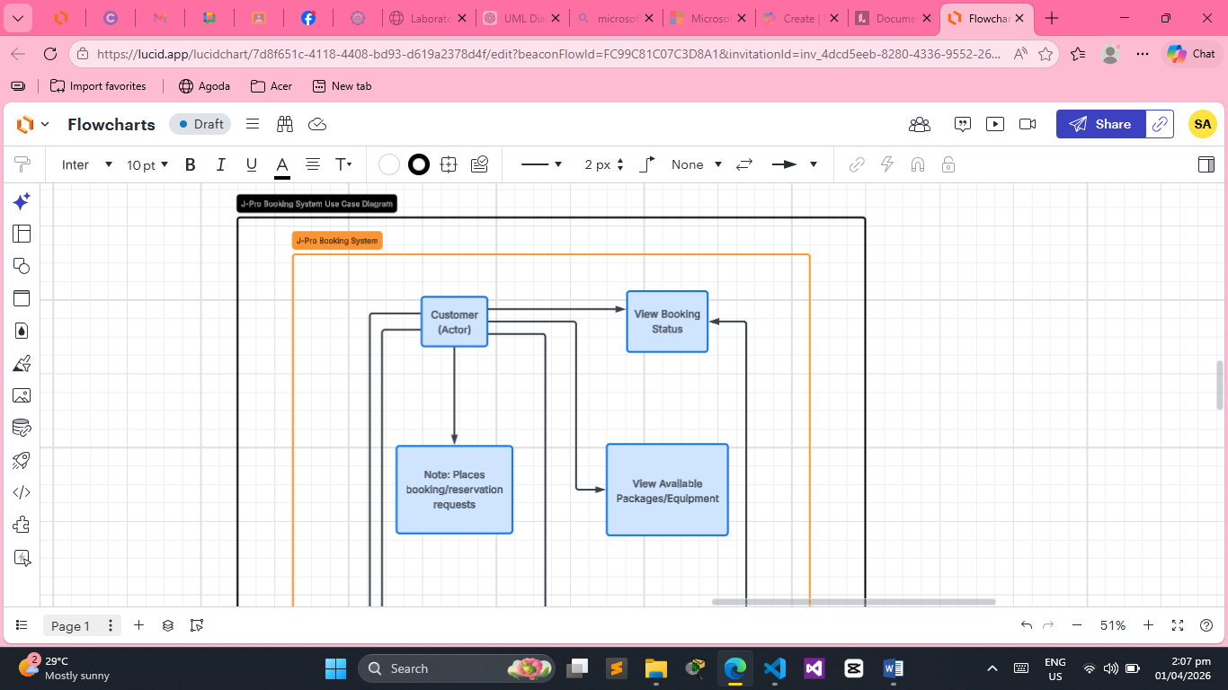
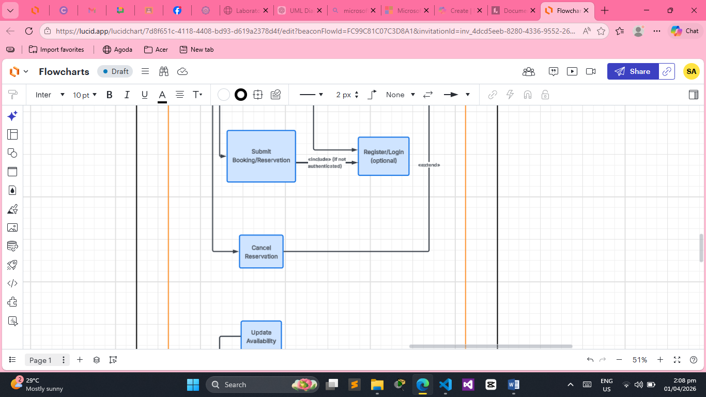
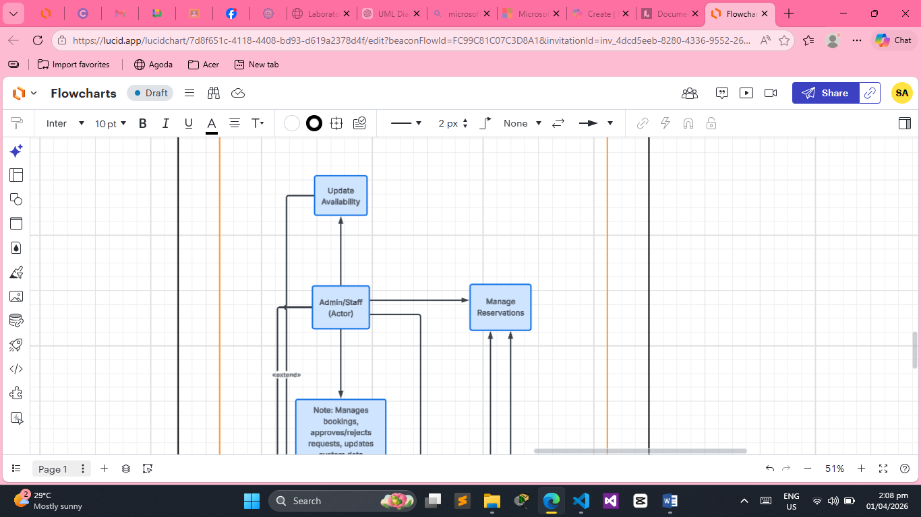
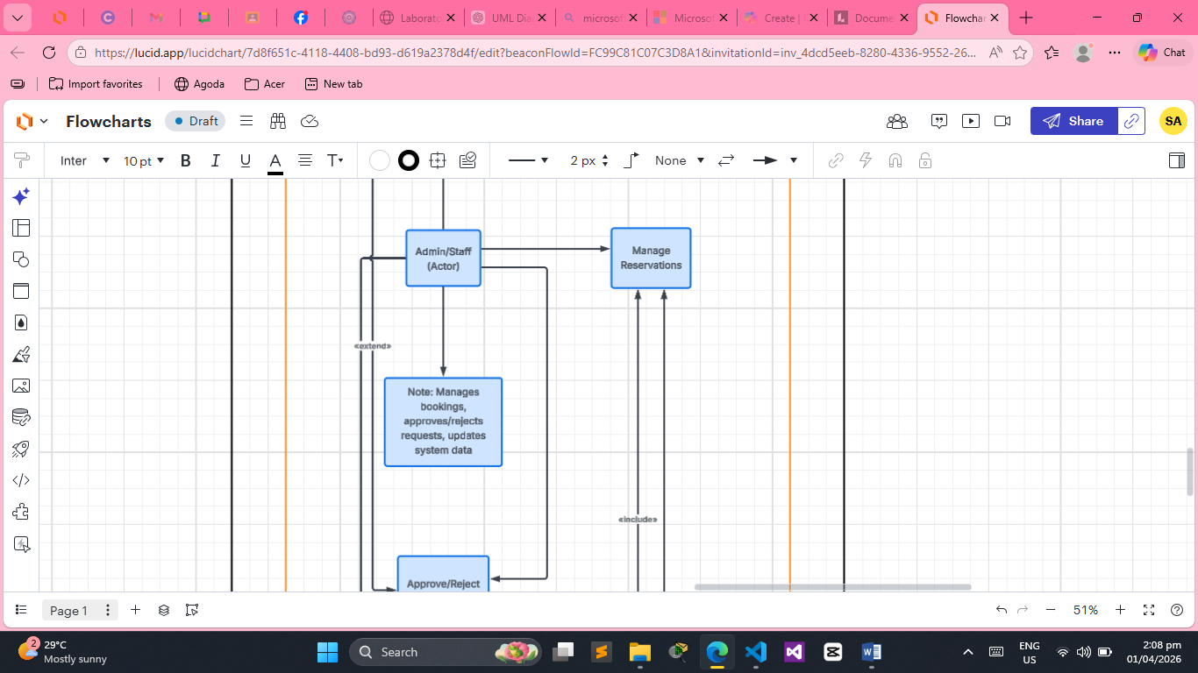
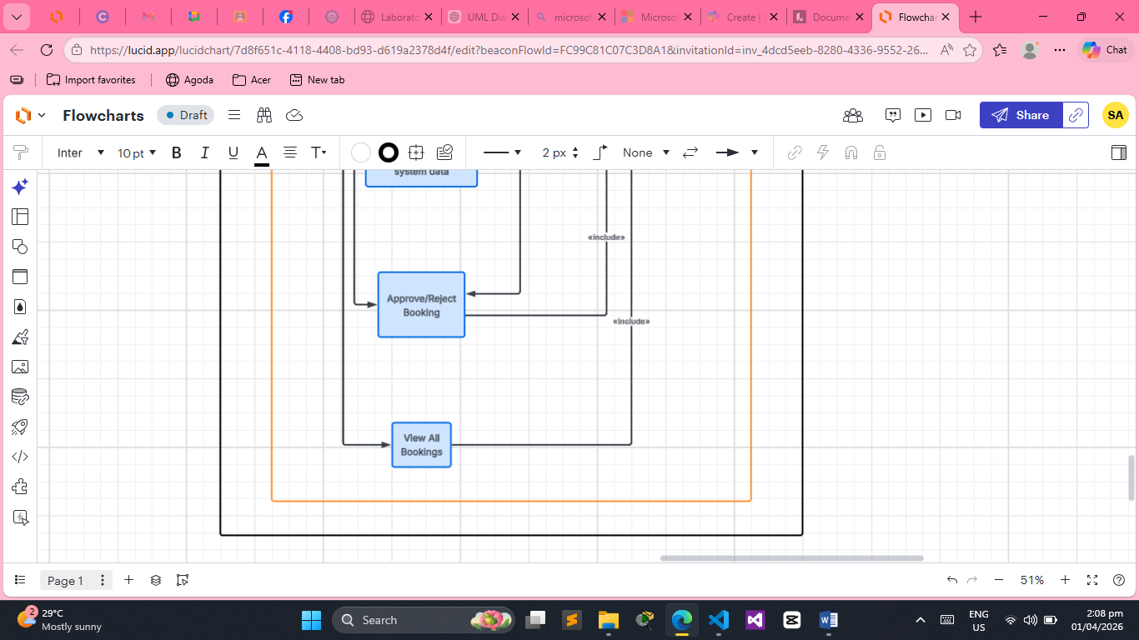
UML DIAGRAM EXPLANATION

The UML Use Case Diagram represents the interaction between the system’s users and its main functionalities. The Customer interacts with the system by viewing services, booking reservations, and checking booking status. The Admin manages the system by approving or rejecting bookings and maintaining availability of equipment. This diagram helps visualize how each actor interacts with the system and defines the system’s core operations clearly.

